**PROJECT REPORT**

**ON**

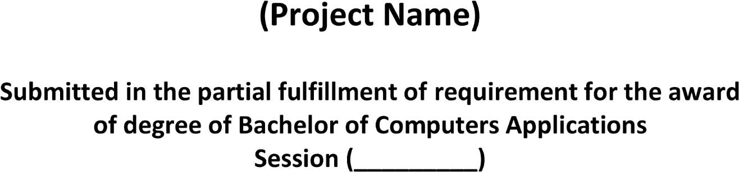

**Forms World**

**2020-23**

**2020 - 2023**

***Ms. Parull Bhardwaj***

***Assist. Professor***

***Shubham Dahiya***

***20012041042***

